ASTR 257 Project 2.5:
Measuring the Period of the Pulsating Variable DY Peg

Overview

Tonight, we were supposed to make a Hertzprung-Russell diagram with multi-color photometry. However, the Nickel imaging camera is offline for repairs. As we learned last night, it is possible to take data with Nickel’s guide camera. However, the guide camera does not have a filter wheel, so measuring the colors of stars is impossible. As observers, it’s our job to make the best possible use of our telescope time, no matter what. That means we need to execute a backup program.

Luckily, there is a good option that will still allow us to flex our photometry skills. We are going to observe the variable star DY Peg and measure how its brightness varies with time. The goal of the lab will be to make a lightcurve (brightness versus time) of DY Peg and measure the period and amplitude of variability.
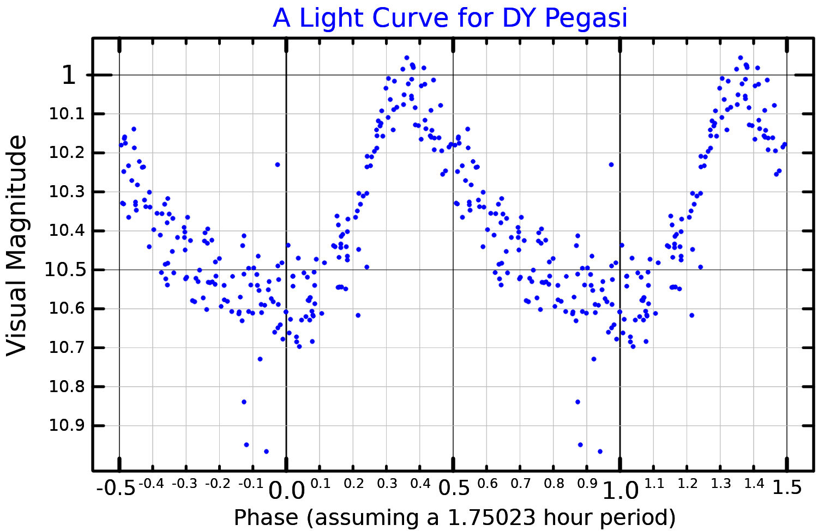
Figure 1: Lightcurve of DY Peg from the ASAS-SN telescope. We will make a similar lightcuve with the Nickel guide camera.

We’ve already used the Nickel telescope, so operations will be straight-forward. But instead of measuring the positions of stars—astrometry—we will measure the brightness of stars—photometry. We will use the Python library Photutils to measure the relative brightness of DY Peg compared to other stars in the field, which we presume are not variable (averaging over many stars in the field will help with this).

Learning Objectives:
- Students will learn to plan and execute imaging observations with the Nickel telescope.
- Students will learn the basics of photometry.
- Students will learn basics of image processing.
- Students will learn basics of database construction.
- Students will learn to present their observations in a standard written format that is appropriate for publication.

Planning Your Observations

Setup
To first order, the observations you will obtain on DY Peg are similar to the ones you obtained on Pluto. So, to prepare for DY Peg, repeat the same steps you used to plan the Pluto observation. Where is DY Peg (use SIMBAD instead of JPL Horizons for stars) and when is it observable? How will you know that the Nickel is looking at the DY Peg field? How long should you integrate? What CCD calibrations will you need? Keep in mind that you are also repeating the Pluto observations tonight, so if you can share calibrations between the two programs, you will save time.

Landolt Standards
You can use the stars in the field surrounding DY Peg to calibrate DY Peg’s variability. In principle, if a cloud goes overhead, all of the stars will get fainter together. However, we also want to know the brightness of DY Peg on an absolute scale. The best way to do this is to look at another star with known brightness, such as a Landolt star. Astronomy hero Arlo Landolt has made a career of cataloging extremely precise photometry measurements on non-variable stars. Landolt’s catalog is available on various websites. As an example, try the WIYN consortium’s listing of recommended Landolt fields:

http://www.wiyn.org/Observe/Landolt/recommendedfields.html

Choose a field that is close in airmass to DY Peg. Close in RA can be a decent proxy for close in airmass, but make sure to think this through. Landolt provides photometry in the UBVRI filters, but we’re operating filterless tonight, so just average BVR.

Approval of Observation Planning
Before we start observing, present your plan of exactly what you’ll be doing. We will have two groups prepare observing plans, but at night, we will have the whole class working together to take data, in order to save time. We will do Pluto first and then spend 3 hours on DY Peg, which will be necessary to measure its period. Last night, you were learning how to use the telescope. Tonight, your job is to be highly efficient observers! Your observing plan should be scheduled down to the minute, including setup and overheads. Always be taking data!

To Be Completed During the Field Trip

Data Reduction
The generic CCD imaging data reduction you did for Pluto applies to this project as well.

Photutils
Photutils is a relatively new software package based on ancient and venerable photometry packages in IRAF and Fortran. In my limited experience with Photutils, I find it reasonably easy to use and well-documented:

https://photutils.readthedocs.io/en/stable/index.html

Use Photutils to perform aperture photometry on your DY Peg and surrounding stars in the field (PSF-fitting photometry is a high-performing alternative to aperture photometry, but is harder to use, so let’s stick with aperture). It will probably take some trial and error to determine the right input parameters. You will also need to run Photutils on the Landolt. You should use the same aperture parameters for all of the stars in your analysis.

You can run Photutils on every image, or you can coadd some images and then run Photutils on the combined frames. You will have a large number of frames no matter what you do, so file organization is going to be important.

Light-Curve
Make a plot of time versus brightness of DY Peg, relative to the surrounding stars. The more stars you use, the less susceptible you will be to the variability of the surrounding stars. However, if you use stars that are low signal-to-noise, it might add noise to your final light curve. You may need to experiment with this.

Once you have a light curve, convert it to absolute magnitudes using your Landolt calibrator.

Writeup (To Be Completed After the Field Trip)

Please write descriptions of your Observations, Reductions and Results. Your Reductions section can be part of the Observations section, or it can be its own separate section. I expect your Observations section to be publication quality, your Reductions section to be clear, but not necessarily at the level of detail seen in publications, and your Results section to be extremely brief, just presenting your calibrated light-curve, period estimate and amplitude estimate.

